Student Team Leader Goals

Student Name: ________________________________________________

As a Run for the Arts Student Team Leader you have a special opportunity to boost enthusiasm and participation for your school’s Run for the Arts. As a team leader, you are eligible to earn a Run for the Arts water bottle by checking of 5 of the boxes below. Do you have an idea that is not on this paper? Check in with your Run for the Arts Coordinator to see if it counts.

Goals
- Make your own fundraising page at runforthearts.ya-or.org
- Visit 3 classrooms to remind students to participate in the Run for the Arts.
- Volunteer at least 2 hours for your Run for the Arts coordinator.
- Brainstorm with other Student Team Leaders ways that you can make your school’s Run for the Arts event successful.
- Wear your Run for the Arts Student Team Leader t-shirt at least 5 times before your Run day.
- Make a Run for the Arts announcement at a school assembly.
- Make a Run for the Arts sign or banner to hang in your school.
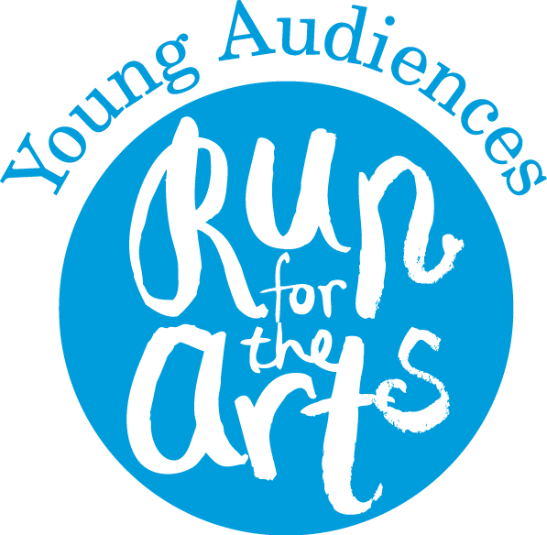
- Write and perform a Run for the Arts cheer for your school.
- Meet with your principal to talk about what you are doing as a Student Team Leader.
- Create your own Run for the Arts training exercises and practice them every week.
- Help lay out the ¼ mile track (Do you know how many feet are in ¼ mile?)
- Earn 50 or more points during your Run for the Arts.
- What other ways can you help make Run for the Arts better at your school?

Coordinator Signature:

_______________________________________________

Memo to Parents
Dear Parents and Guardians,
Young Audiences is a nonprofit arts organization that works to inspire young people and expand their learning through the arts. Since 1977, Young Audiences has helped schools and students raise funds for in-school arts programs with Run for the Arts. The money raised will be used for performances, workshops and residencies with professional teaching artists; field trips; and art supplies.
Your child’s participation in the Run is voluntary, however I hope you will encourage him or her to join in, have fun, and support our school. I also invite you to help out by volunteering before, during, or after the run with our Run for the Arts school coordinator.
Our school coordinator: ___________________________________________________________

Please help your child in the following ways:
- Read the Run for the Arts Sponsor Sheet that your child brings home.
- Sign the “Parent/Guardian Agreement” and fill in a t-shirt size for your child. T-shirts are one of the potential prizes your child can earn.
- Register your child to collect online donations on runforthearts.ya-or.org. Students can collect donations online, in person, or both.
- Please assist your child in collecting sponsorships from family, friends and neighbors by sharing the online link or by collecting in person donations.
- Help your child follow the timeline listed below so deadlines are not missed.
Sponsor Sheets Due | Run for the Arts Date | Rain Date | Funds Due
_____________ | _____________ | _____________ | _____________
End of the Pledge Period. Sponsor Sheets must be turned in to the school on this date. | School Run Day. After the Run, Sponsor Sheets will be returned to students for the Collection Period. | Parents will be notified if Run date is changed. | End of the Collection Period. Funds and Sponsor Sheets MUST be turned in to the school by this date.

With your help, our school will have an outstanding Run for the Arts. Thank you!

Memo to Runners

From: ____________________________________ , Run for the Arts Coordinator
Re: Run for the Arts

Before the Run

- CAREFULLY READ the instructions on your Sponsor Sheet. Have all sections filled out before the Run. Don’t forget your parent's signature!
- Register for online donations at runforthearts.ya-or.org
- Bring your Sponsor Sheet to school on _____________________ so we can record your laps during the Run. (date)

Run Date: ____________________________________

After the Run

Encourage sponsors to make payments online or by check. Checks should be made payable to Young Audiences or Run for the Arts. The pledged money is tax-deductible; if sponsors ask, you can have them read the “To the Sponsor” section inside your Sponsor Sheet.
- Be sure to thank your sponsors for their support of your school’s Run for the Arts.
- All physical funds and sponsor sheets MUST be turned in to the school by _____________________ in order for you to be eligible for awards. (date)

Have a great run!

Memo to Teachers

From: _____________________________________, Run for the Arts Coordinator
Re: Run for the Arts
We’re off and running for the arts! You and your enthusiasm are essential for our school's success in this project. Thank you in advance for your time and energy.
Students can collect donations online! Students need to register at runforthearts.ya-or.org and share their link with friends and family. Any way that you can encourage them to do this is helpful.
Although the true reward of the Run for the Arts is the arts experiences our students receive, t-shirts and prizes are great motivators. Please remind your students that it takes 30 or more points to earn a Run for the Arts t-shirt. Scores are determined by the formula: (2 x # of paid sponsors) + (# of laps completed). The students with the highest and second highest scores in our school will earn additional prizes. All participants with at least one paid sponsor and one lap run will earn Participation Awards.

IMPORTANT DATES
Distribute Sponsor Sheets: _______________ Pledge Period Begins: _______________

1st Deadline: End of the Pledge Period: _______________
(Students return Sponsor Sheets before the Run)
Our Run Date: _______________ Alternate Rain Date: _______________
Collection Period Begins: _______________
(Sponsor Sheets are returned to students after the Run so they can begin collection of funds.)
2nd Deadline: End of Collection Period: _______________
(Students return funds and Sponsor Sheets)
Please explain to your students how to participate in Run for the Arts and what they will receive (both prizes and arts programs). Students may not sponsor each other.
Questions about the Run? please contact me at _______________ or Young Audiences at (503) 225-5900.
I look forward to working together to make our Run for the Arts a real success. Thank you!
Memo to Volunteers

From: ___________________________________, Run for the Arts Coordinator
School: ___________________________________
Phone: ___________________________________

Thank you for your interest in volunteering for the Young Audiences Run for the Arts. The Run will help bring arts programs, supplies, and experiences to our students throughout the coming school year. We appreciate your willingness to help out where you can!

Schedule

You are scheduled to volunteer on: _____________________
Please arrive at the school at: _____________________

Thanks Again!

Date

What a great job for a volunteer!
Have them choose 10–20 local businesses, fill in the blanks, and mail or hand them out!

Contact name (if you have it)
Organization
Address
Zip, City State

Dear Local Business

I am writing you about an upcoming event at Name of School in your neighborhood. Our school will be participating in the Young Audiences’ Run for the Arts fundraiser this year on Date of Run. Run for the Arts helps our school raise money to support arts programs throughout the year.

We are hoping to include more community members and local businesses in our efforts and invite your business to take part. We are asking you to contribute $200 – $500 or an amount that is comfortable for your organization.

All sponsoring businesses contributing more than $100 will receive a special community supporter thank you in our parent newsletter that goes out to [Number of Students] local families.

If your organization would like to participate in this year’s event as a sponsor, please contact me with the amount of your donation. All donations should be made out to “Run for the Arts” and are tax exempt.

Thank you for your time and consideration.

Sincerely,

<Your Name>
Run for the Arts Coordinator
School Name
School Address
Email Address (if you would like to be contacted by email)

This is a sample. This template and all other memos available on our website ya-or.org.

