Using Title Funds for Arts Education
How the Every Student Succeeds Act (ESSA) expands arts-learning opportunities for students

youngaudiences@ya-or.org 503-225-5900 1220 SW Morrison St Portland, OR 97205

With the adoption of ESSA in 2015, federal education law’s focus on “core academic subjects” was broadened to encompass all the aspects of a “well-rounded education”—including, by definition, the arts. This gives schools and districts more flexibility to use Title I funds to support arts programming for their students.
Schoolwide Programs
As part of a “well-rounded education,” the arts can be included in plans for schoolwide improvement programs. Depending on the results of a school’s needs assessment, that could mean arts courses that expand the curriculum or co-curricular arts programs that engage students and can strengthen school climate and culture.

Targeted Assistance Schools
Unlike previous versions of federal education law, ESSA opens the door for targeted assistance schools to use the arts to help specific groups of students meet academic standards. Potential arts-based strategies include arts courses for targeted students during the school day, an afterschool “makers” program integrating the arts into STEM learning, or a summer arts program.

District Title Funds
Under ESSA, districts can now use Title funds to:

- provide arts educators with professional development, as well as develop programs using arts-based techniques or arts-integrated strategies to build the capacity of teachers.
- support well-rounded education opportunities based in the arts, such as arts-integration programs
- invest in extended-day 21st Century Community Learning Centers that feature arts programming

Ask your district staff for more information.

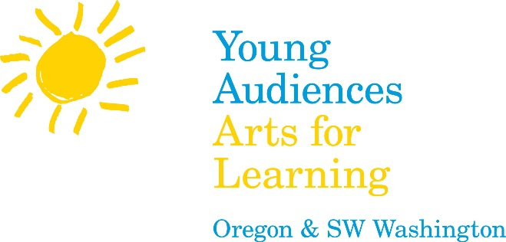
We know finding funding for the arts can be difficult. We’re here to help.

If you have questions about Title funding for arts education, please contact Programs Director Kristi Riedel at kristi@ya-or.org or (503) 225-5900 x226.

